**CONFERENCE MANAGEMENT SYSTEM**

**Project Team Members and Their Responsibilities :**

* Emre Cinoğlu – *Front – End Developer*
* Dursuncan Aydemir – *Back-End Developer*
* Yasemin Nukan - *Front – End Developer*
* Barış Temiz – *Test and Documentation*

Conference management system manages all administrative and organizational tasks of a conference. The system is a server side web application that uses external relational database management system.

Conference Management System will provide :

* *Login Authentication*
* *Conference Rooms and Presentation Scheduling*
* *Announcements*
* *Registrations*

We use **HTML , CSS , Bootstrap , C# and Javascript** programming languages in our project.

**Registrations :**

In registration phase , user information put into the database. After registration , users can sign in and access to the system.

Users data will include the following:

1. **Name**
2. **Surname**
3. **E-mail**
4. **Contact Info**
5. **Password**

**Login Authentication:**

The function specifies the signing-in process of the Conference Management System. E-mail and password will require for login the system.

Login Authentication will include the following :

* **E-mail Field:** Users will put their e-mail addresses in this field. E-mail address is used for identification of a user.
* **Password Field :** Users will put their passwords in this field. Users can change their passwords after login.

**Conference Create:**

Users click “Create New Conference” link on their homepage. After the required fields are filled and a conference is created, the conference is automatically created and come on the users homepage.

Required information will include the following:

1. **Name of Event**
2. **Description**
3. **Start Time**
4. **End Time**
5. **Date**
6. **Conference Rooms**

**Conference Rooms and Presentation Scheduling:**

The system should be able to determine the conference rooms and schedule the presentations using the information provided by conference admins while filling in the conference create form. This process will done automatically.

Scheduling process will include the following :

* **Conference Rooms Panel :** Users will need to give information about number and capacity of the rooms.
* **Conference Time Panel:** Users will need to give information about time requirements of conferences.

**Announcements:**

This is the process which will announce all updates and details about conference. Conference admins will make announcements for their conferences.

Announcements will provide the followings:

* **My Conference Page:** Users will view all conferences that they are participating in this page.
* **View Conference Page:** Schedule and announcements of a selected conference will be viewed in this page.
* **Make Announcement Page:** Conference admins will make announcements for a selected conference using this page.

**Functional Requirements :**

* Server should check if the e-mail and password entered by the user are valid or not.
* Every participant of a conference will be able to view conference papers and their evaluations.
* A user will only be able to submit a paper for a conference if he or she was invited as an author.
* All users will be able to download and view properties of a paper.
* Users will only be able to evaluate papers if they were invited to a conference as a referee.
* A referee will only be able to evaluate papers he or she was assigned to.
* All users will be able to create and manage their own conferences. The admin will approve the created conferences.

**Nonfunctional Requirements :**

**Safety Requirements**

System has to check HTML content is syntactically well , statically safe binding of the code of session operations to variables defined with session scope. In case of error , it should provide user with send help messages.

**Software Quality Requirements**

The system will have a simple and user friendly graphical interface. Users will be able to understand and use all the features of the website easily. Any action will be performed with just a few clicks.

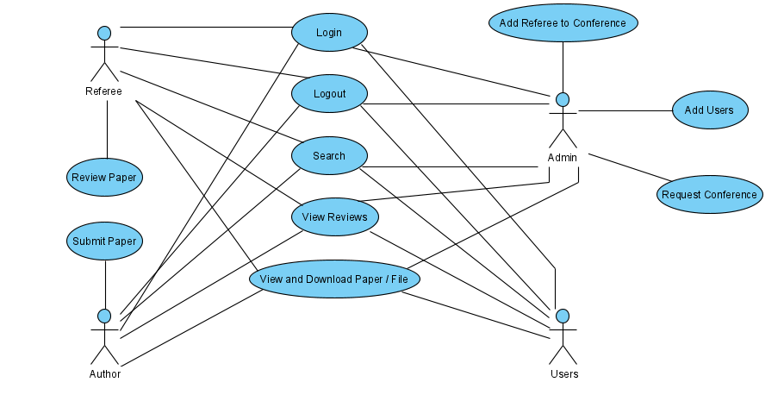

**Use Case Diagram for Conference Management System**

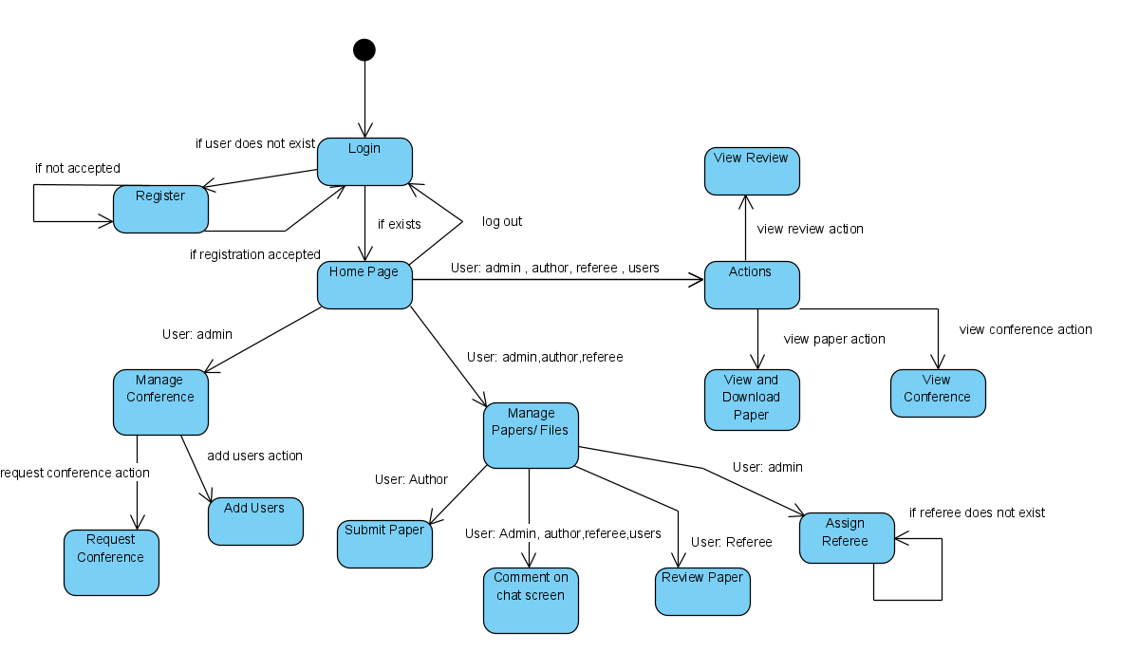

**State Diagram for Conference Management System**

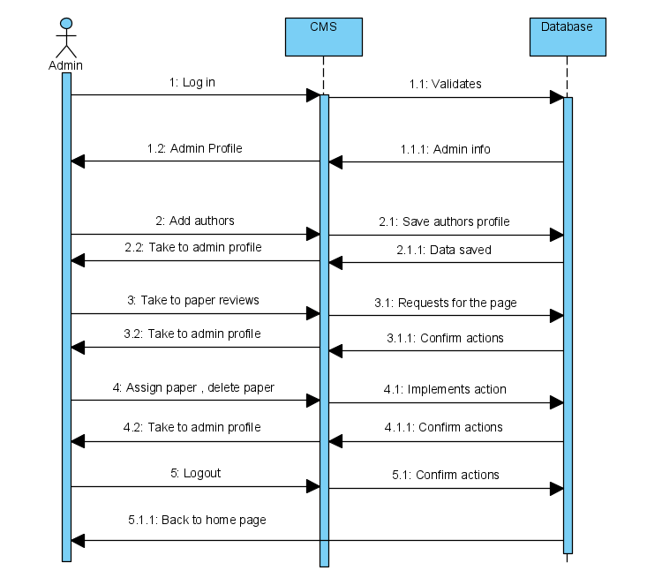

**Sequence Diagram showing admin interaction with the system**

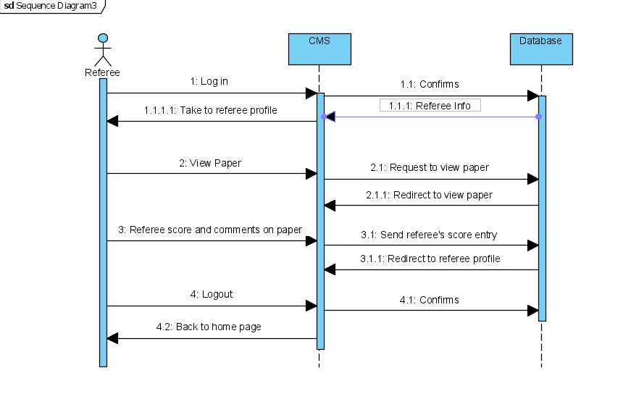**Sequence Diagram showing referee interaction with the system**

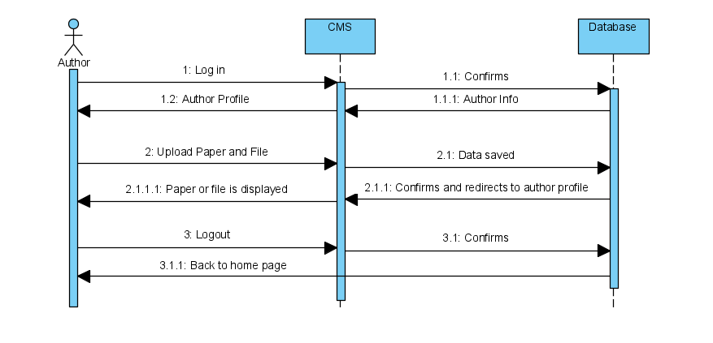

**Sequence diagram showing author interaction with the system**

**TEST ENVIRONMENT AND SCENARIOS**

**Test Environment:**

Our system will be tested on various web browsers to check for compatibility issues.

These browsers include Mozilla Firefox, Opera and Google Chrome etc.

**Scenarios:**

1. **Register**

The first step is registering to the system. For this purpose, user should provide

an name, surname, password, gender, user type and e-mail address.

Steps:

* Click “Register” button on login page
* Fill in all necessary fields
* Click “Register” button

Outcomes:

* If the username or mail address already exists, an error message will be

displayed

* If all necessary fields are not filled, an error message will be displayed

1. **Login**

To login to the system, user should provide a username and a password.

Steps:

* Enter username and password
* Click “Login” button

Outcomes:

* If the username or password is incorrect, an error message will be displayed.
* If all fields are correct, user will login and be redirected to home page

1. **Conference Request**

Users and referees can send request to create or add a conference/room to the system.

Steps:

* Go to home page and click “Add New Room” button
* Fill in all fields
* Click “Save” button

Outcomes:

* All attributes of the new conference/room will be inserted into database after the

button is pressed

1. **Conference/Room View**

All users can see all conferences and details of the conference.

Steps:

* Go to home page and click on the any room/conference.
* Come to the left of the conference tab and click the "Exit Room" button next to your name.

Outcomes:

* System shows detailed descriptions of the conferences, papers and participants.

1. **Delete Conference**

Only system admin can perform this action. Conference is deleted from system.

Steps:

* Go to a Room Management tab.
* Click “Rooms” button on left of page.

All conferences will be listed.

* Click delete button on the right of the conference name.

Outcomes:

* Conference is successfully deleted from DB.
* Users, Referees, Authors are not getting any notification.

1. **View User Profiles**

From home page, a logged in user can display her/his profile page. This feature can be

used with following steps:

* Go to “Home” page
* Left click on “Profile” link

In this page, these information and functionalities are shown:

* User Type
* First Name
* Last Name
* e-mail
* Conferences (which he/she participated)
* Papers

Outcomes:

* For displaying e-mail, conferences and papers according to the user , related sections can click.

1. **View Notifications**

Steps:

* Go to home page
* Left click on Notifications icon
* Click on any notification and view this notification

Outcomes:

* In this page, all notifications can be displayed.
* The last 3 notifications are constantly displayed in the notification tab.

1. **View Paper**

Steps:

* Click on Home Page and enter any conference or room and view this conference’s or room’s papers/files.
* Click on the paper/file then users can view and download this paper/file.

Outcomes:

* Users can view and download paper/file on this conference/room.